|  |  |
| --- | --- |
| TEAM ID | PNT2022TMID11641 |
| PROJECT NAME | Analytics for Hospitals' Health-Care Data |
| MAXIMUM MARKS | 2 Marks |

|  |  |
| --- | --- |
| Marketing Spend and Administration by R&D Spend  Column Line  Administration (Sum) Marketing Spend (Sum) | o |

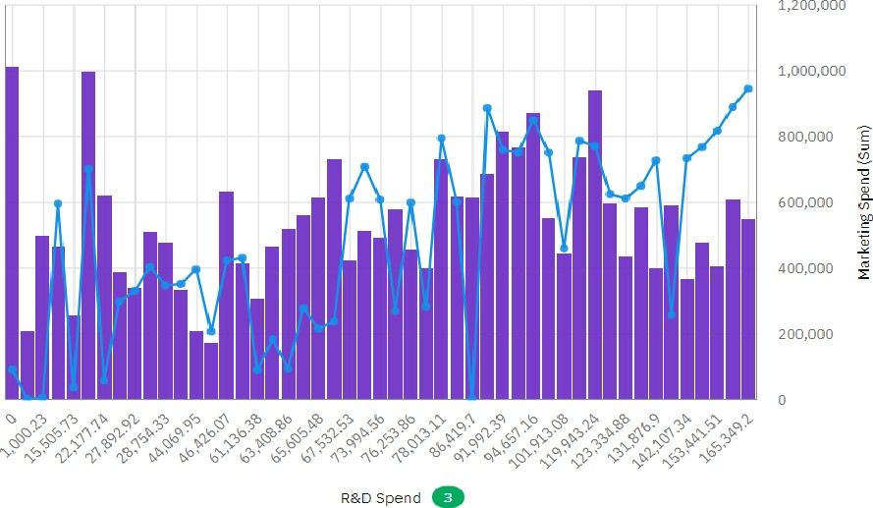600,000

500,000

 400,000

300,000

 200,000

100,000

o

|  |  |  |  |  |  |  |
| --- | --- | --- | --- | --- | --- | --- |
| Chart A |  |  | Chart B |  |  |  |
| Marketing Spend by State O | State | o | Profit by State | o | State | o |

 California California

New York Florida Florida New York

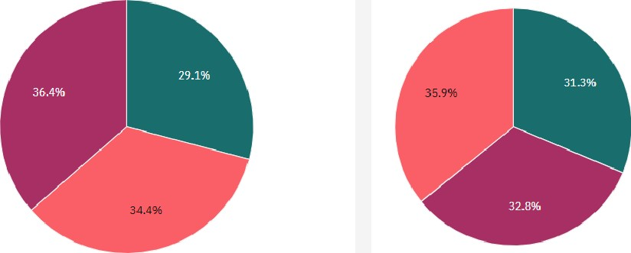

Marketing Spend and Administration by State

Measures

 Marketing Spend Administration

9,000,000

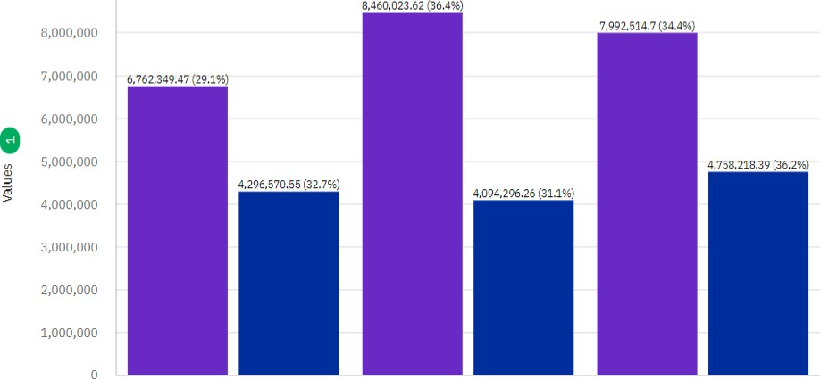

California Florida New York

State

Profit for State o

Column values

Increase Decrease Sum

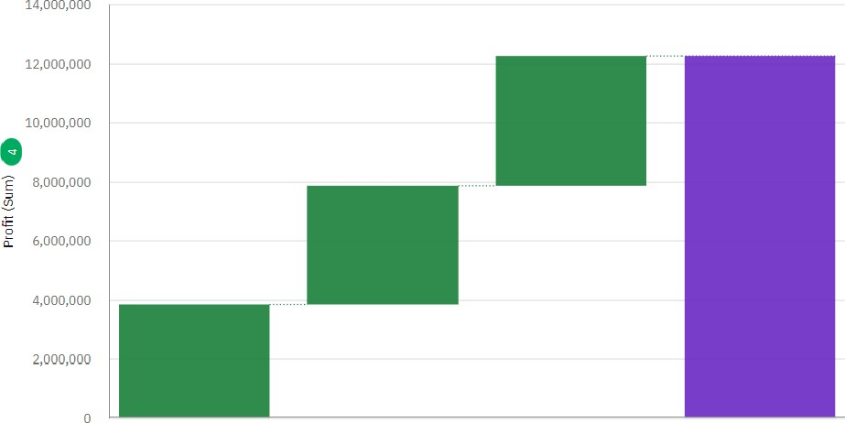

California Florida New York Sum

State

Profit by R&D Spend o

450,000

|  |  |  |  |  |  |
| --- | --- | --- | --- | --- | --- |
|  | 3.5% | Average: 250,216 | 3.1% | 3.5%  3.5%  3.2%  3.3%  3.1% | |
|  |  |
|  |  | 1.1% | |  | |
|

400,000

350,000

300,000

250,000

200,000

150,000

100,000

50,000

o 15,505... 27,892... 44,069... 61,136... 65,605... 73,994... 78,013... 91,992... 101,91... 123,33... 142,10...

1,000.23 22,177... 28,754... 46,426... 63,408... 67,532... 76,253... 86,419.7 94,657... 119,94... 131,87... 153,44...

spend

Profit and Administration for State regions O

Profit (Sum) Administration (S...

